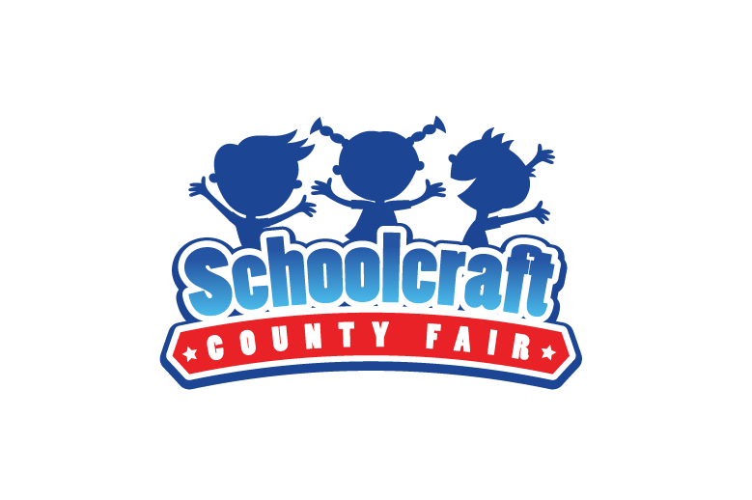
Premium
and
Exhibit
Guide

Hello,

The Schoolcraft County Fair is an independent 501(c) (3) non-profit organization with no formal or informal affiliation with any governmental agency or unit at the local, state or federal level; including the County of Schoolcraft. Our fair board and its’ members are all volunteers and serve without any compensation for their time and effort.

Each year, farmers, students, homemakers, community members and all area residents are invited to exhibit products that they have grown or projects that they have made themselves. Even if you do not see your item specifically listed, please still bring it to register and exhibit-it in the fair’s premium show. There are numerous other classes and categories that are not listed.

The Schoolcraft County Fair Board sincerely hopes that this event will continue to grow through the participation of people throughout this area. There will be some old-time favorites and some new surprises, so make sure to stop by the fairgrounds during this year’s fair.

We hope to see you there!

Sincerely,

Cathy Rohde

President, Schoolcraft County Fair Board

1. Classes are open to residents of Schoolcraft County and all surrounding communities.
2. All exhibits must be made during current year, except where noted.
3. One entry per class, per exhibitor, except where noted.
4. Exhibits from previous years are welcome to be displayed, however they won’t be judged and no ribbons, prizes or premiums will be awarded.
5. Exhibit Registration: Still and Live Exhibit Registration will be held at the Schoolcraft County Fair Building located at 139N Lake St in Manistique, Michigan. Dates and times are listed on the annual Fair Week Schedule.
6. You will be assigned an Exhibitor Number and your exhibit will be tagged for display.
7. No exhibitors will be allowed in the building or barns during judging.
8. The Danish system of awarding ribbons will be used, with A (blue), B (red), C (white) or Best of Show (purple) ribbons given to each exhibit in each class. Ribbons will be awarded in both Open and Youth classes.
9. Premiums will be awarded in Open classes as follows: Best of Show-$3, Blue Ribbon-$2, Red Ribbon-$1, White Ribbon-50 cents. Payment of all premiums will be made on Sunday following the fair. The last four digits of an exhibitor’s social security number may be required. Premiums in Youth Classes are as follows: Best of Show-$2, Blue Ribbon-$1, Red Ribbon-50 cents, and White Ribbon-25 cents.
10. In any class where trophies or rosettes are awarded, no premiums will be issued, except where noted.
11.. All exhibits may be picked up on Sunday, following the fair, along with your premium. payment, prize or certificate. Other exhibits not removed at this time may call (906) 286-9185 to arrange a time to pick up their items.
12. Not responsible for exhibits, premiums or prizes not picked up by August 21st.

Appeals and Complaints
An exhibitor compelled to bring a complaint regarding conflict of interest of the judge, disqualification of an exhibit or exhibitor, exhibitor, group leader or superintendent’s behavior, or eligibility of an exhibit shall make a formal protest in writing to the Fair Board no later than ten days following the end of the fair.

All protests shall be referred to the Executive Board, which shall review the protest with interested parties and give parties an opportunity to submit evidence. The party against whom the protest was filed shall have the right to read the statement of protest.

A report of findings shall be made to the Fair Board for final decision on the protest within ten days of the original complaint. The Fair Board shall issue an opinion within 2 weeks of receiving the recommendations from the Executive Board.

An exhibitor may file an appeal to the Dept. of Agriculture within 45 days of filing the initial complaint if the exhibitor is not satisfied with the Association’s action.

Registration and Premium/Award Information
Open and Youth Classes
NOTE: Live Animal Exhibits:
The Schoolcraft County Fair Board
has decided to NOT have
live animal exhibits at the 2026 Fair.

Exhibit Premiums and Awards

Best of Show Open $3 Youth $2
Open – Blue Ribbon (1st)-$2 Red Ribbon (2nd)-$1 White Ribbon (3rd)-50 cents
Youth- Blue Ribbon (1st)-$1 Red Ribbon (2nd)-50 cents White Ribbon (3rd)—25 cents

Registration and Premium/Award Information
Open and Youth Classes
NOTE:
Live Animal Exhibit Registration: Due to the continued discovery of the highly pathogenic avian influenza (HPAI) throughout the state, the Schoolcraft County Fair has decided not the have live exhibits in the barn during the 2024 Fair

Still Exhibit Premiums/Prizes Awarded a Follows:

Best of Show Open $3 Youth $2
Open – Blue Ribbon (1st)-$2 Red Ribbon (2nd)-$1 White Ribbon (3rd)-50 cents
Youth- Blue Ribbon (1st)-$1 Red Ribbon (2nd)-50 cents White Ribbon (3rd)-Ribbon Only

